1
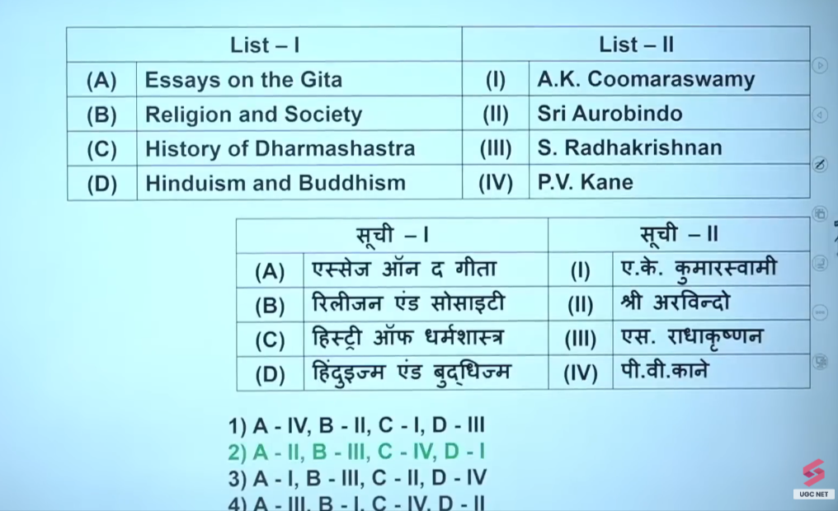

2
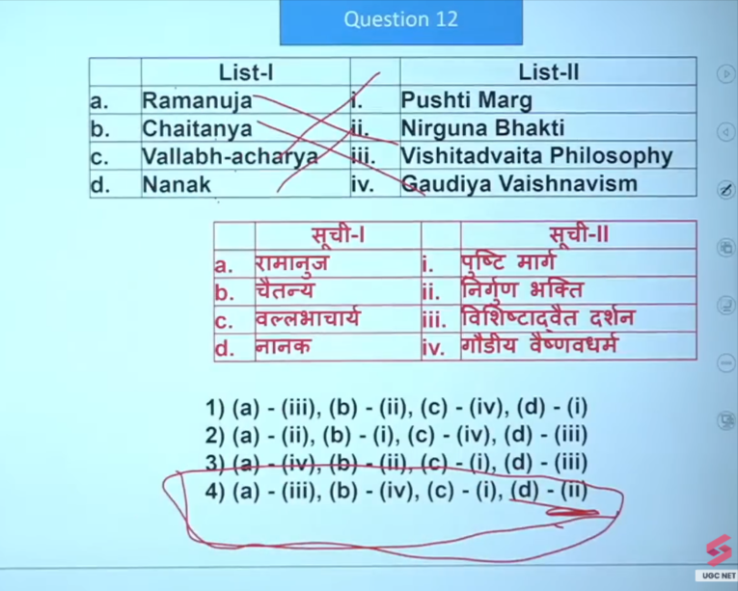

3
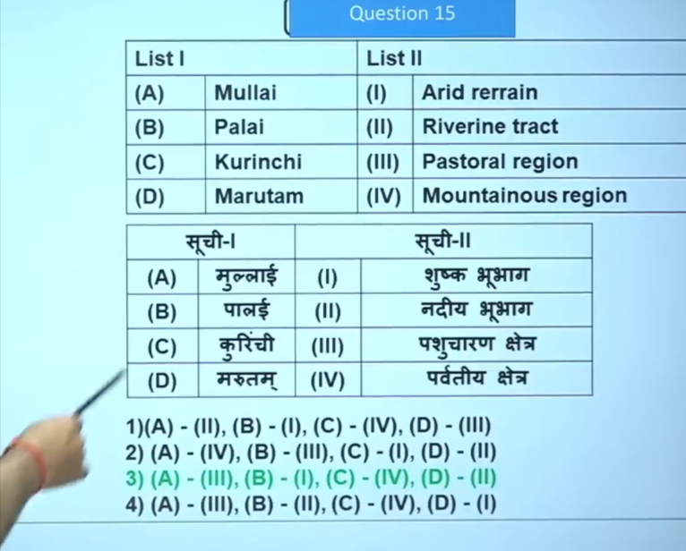
Yes, Mullai is the pastoral region in the Tamilakam five-fold landscape classification (Ainthinai) of the Sangam Age, representing forested and grassland areas. Characterized by cattle-rearing and dairy farming, this region is associated with the deity Mayon (Vishnu), with inhabitants often known as Idaiyar.

Palai (or Palai) is one of the five geographical landscapes (Tinais) defined in ancient Tamil Sangam literature, representing a parched, dry, and arid landscape. It is frequently described as a wasteland or desert, often formed when other regions (Kurinji/mountains or Mullai/forests) dry up during periods of drought or intense heat.

Kurinji is the mountainous, "hilly track" eco-region in ancient Tamilagam (Sangam literature), characterized by lush forests, verdant slopes, and the Neelakurinji flower (Strobilanthes kunthiana) that blooms every 12 years. Primarily covering the Western Ghats and parts of the Eastern Ghats, this region was traditionally inhabited by the Kuravar tribe, focusing on hunting, gathering, and early agriculture.

Yes, Marutam (or Marudham) is classified as the riverine tract in the Sangam landscape concept. It represents the fertile agricultural plains of ancient Tamilakam, characterized by the following:
- Landscape: Riverine, alluvial, and fertile agricultural plains.
- Economic Activity: Cultivation, agriculture using ploughs, and irrigation.
- Associated Crops: Paddy (rice) and sugarcane are commonly associated with this region.
- Cultural Context: In Sangam literature, this landscape is associated with the theme of Oodal (lovers' quarrels).
- Name Origin: The region is named after the Marutam (Lagerstroemia speciosa) tree.
Marutam is one of the five tinais (geographical divisions) along with Kurinji (mountains), Mullai (forests), Neytal (coastal), and Palai (arid).

4
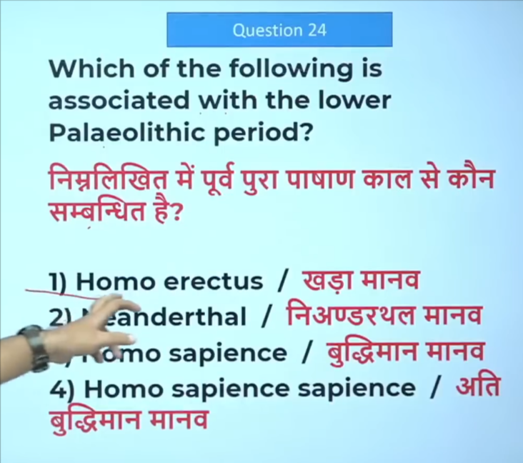

Second

5
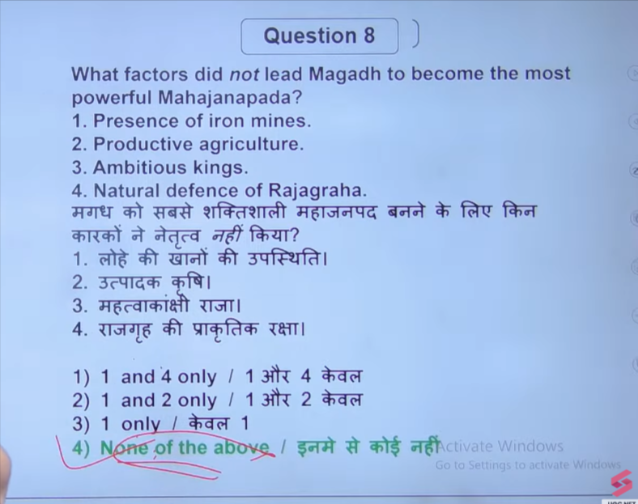

6
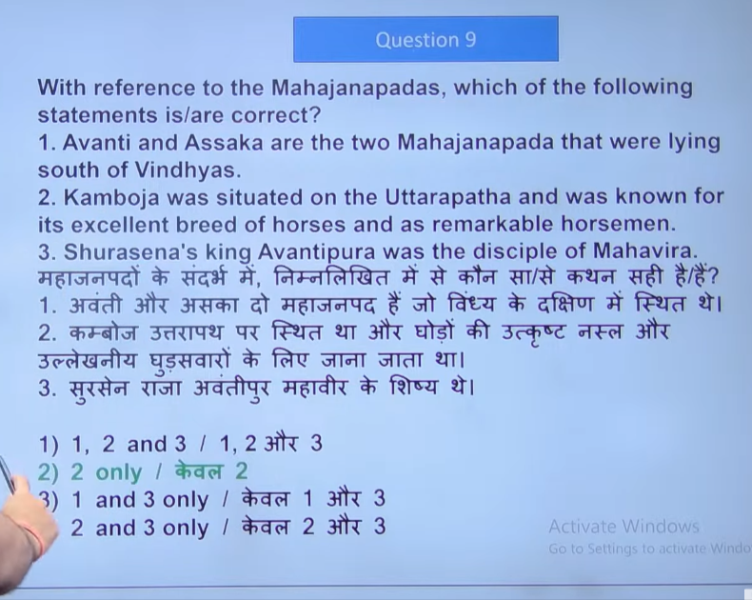
7

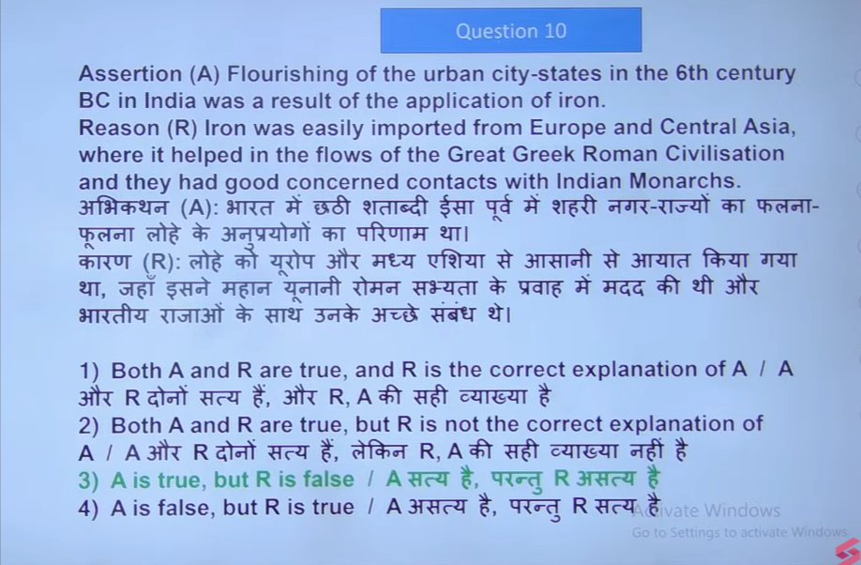

8
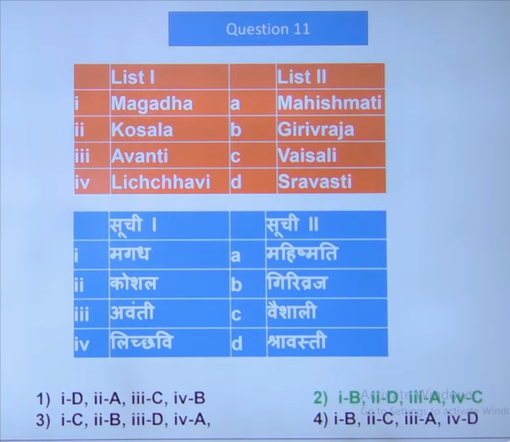

9
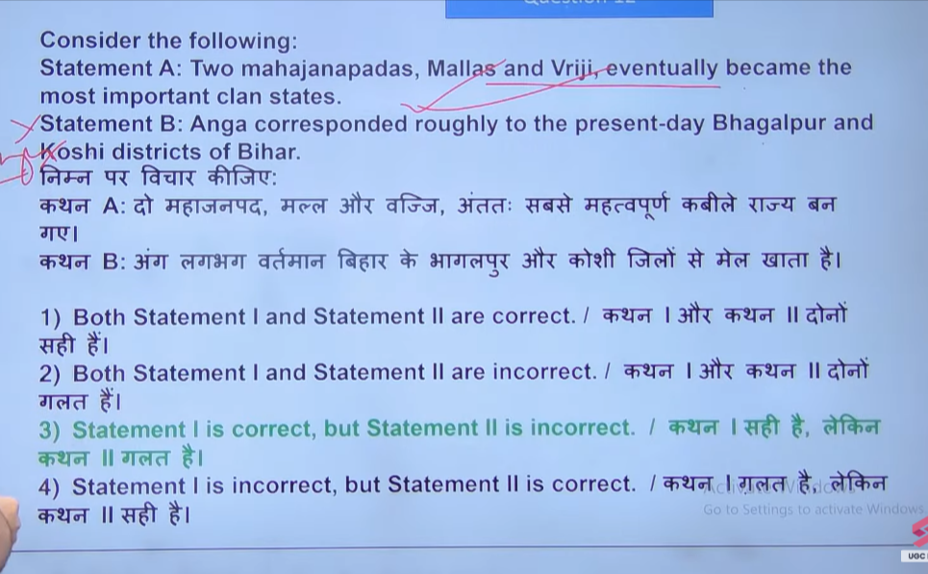
10
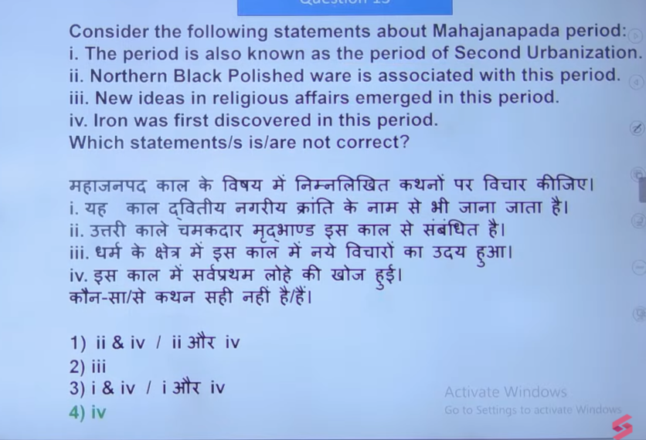

11
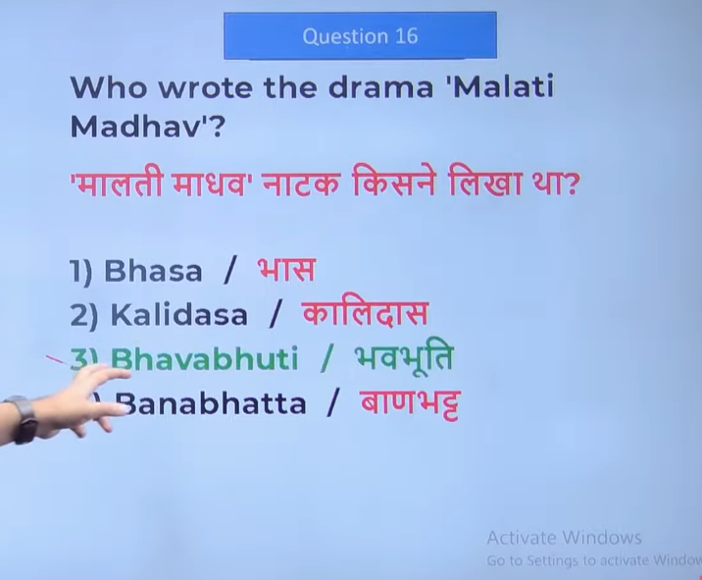
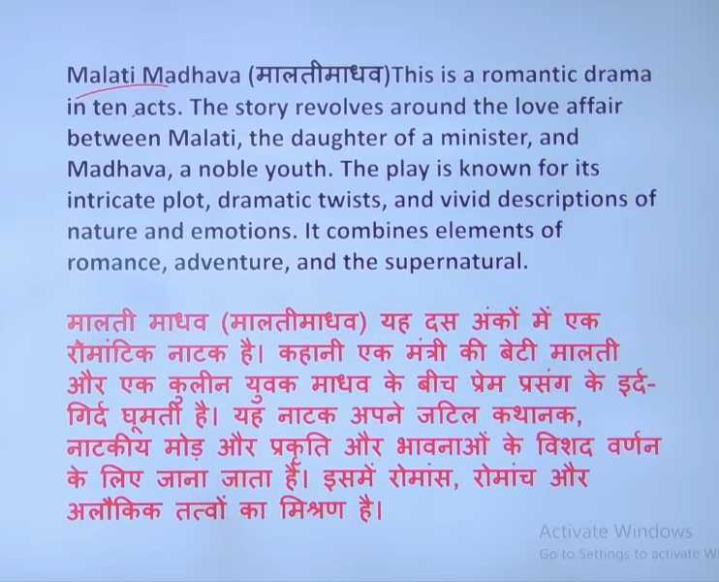
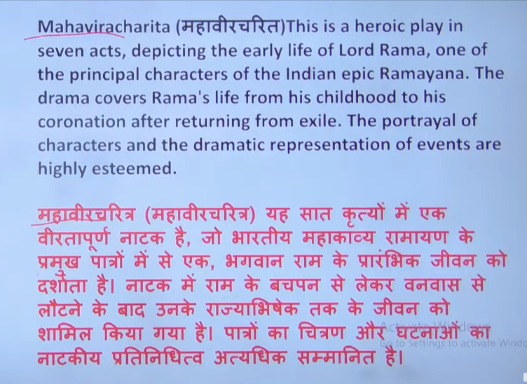
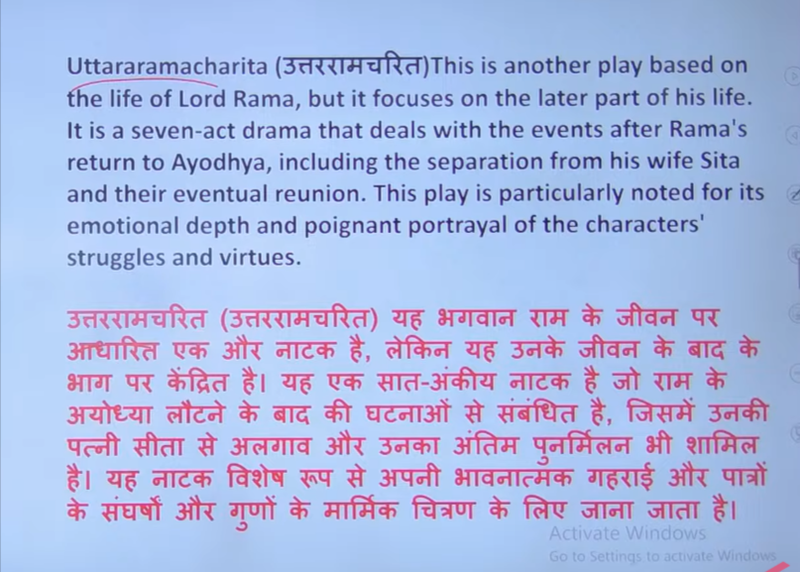

12
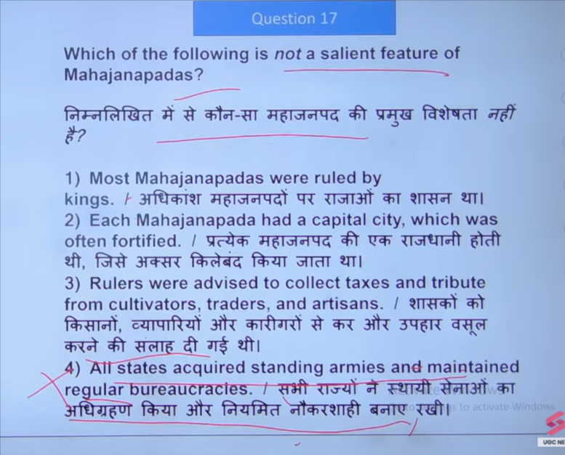

13
